**ROLL NO:-32**

**Name:- Dhake Nikhil Manohar**

**Practical No:-5**

**Practical Name:- Use git PULL to get your partners change into your repository.Verify that you have the new.**

Nikhil@Dknik MINGW64 ~/KBC (main)

$ git version

git version 2.36.1.windows.1

Nikhil@Dknik MINGW64 ~ (master)

$ git clone https://github.com/dkniik/KBC.git

Cloning into 'KBC'...

remote: Enumerating objects: 3, done.

remote: Counting objects: 100% (3/3), done.

remote: Total 3 (delta 0), reused 0 (delta 0), pack-reused 0

Receiving objects: 100% (3/3), done.

Nikhil@Dknik MINGW64 ~ (master)

$ cd KBC

Nikhil@Dknik MINGW64 ~/KBC (main)

$ git init KBC

Initialized empty Git repository in C:/Users/Nikhil/KBC/KBC/.git/

Nikhil@Dknik MINGW64 ~/KBC (main)

$ touch new.text

Nikhil@Dknik MINGW64 ~/KBC (main)

$ git add new.text

Nikhil@Dknik MINGW64 ~/KBC (main)

$ git commit -m "first commit"

[main a9fac35] first commit

1 file changed, 0 insertions(+), 0 deletions(-)

create mode 100644 new.text

Nikhil@Dknik MINGW64 ~/KBC (main)

$ git config --global user.email "nikhiildhake@gmail.com"

Nikhil@Dknik MINGW64 ~/KBC (main)

$ git config --global user.name "dkniik"

Nikhil@Dknik MINGW64 ~/KBC (main)

$ git commit -m "first commit"

1 file changed, 0 insertions(+),0 deletions(-)

create mode 100644 new.txt

Nikhil@Dknik MINGW64 ~/KBC (main)

$ git push -u origin main

Enumerating objects: 4, done.

Counting objects: 100% (6/6), done.

Delta compression using up to 12 threads

Compressing objects: 100% (4/4), done.

Writing objects: 100% (6/6), 1.83 bytes | 117.00 KiB/s, done.

Total 3 (delta 0), reused 0 (delta 0), pack-reused 0

To https://github.com/dkniik/KBC.git

f6c1584..351b0b6 main -> main

branch 'main' set up to track 'origin/main'.

Nikhil@Dknik MINGW64 ~/KBC (main)

$ git pull https://github.com/dkniik/KBC.git

remote: Enumerating objects: 6, done.

remote: Counting objects: 100% (6/6), done.

remote: Compressing objects: 100% (4/4), done.

remote: Total 6 (delta 0), reused 0 (delta 0), pack-reused 0

Unpacking objects: 100% (6/6), 1.83 bytes | 117.00 KiB/s, done.

From https://github.com/dkniik/KBC.

* branch HEAD -> FETCH_HEAD

**Before Pull:-**

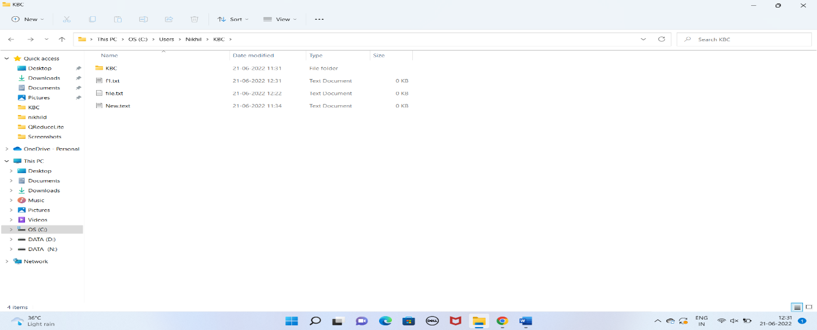

**After Pull:-**

